The question particle (Q) mI in Turkish is often regarded as an enclitic that marks Yes/No (YN) questions (Kornfilt, 1997) and it also acts as a question focus particle (Göksel & Kerslake, 2005). In YN questions, mI can follow almost any constituent and its position marks the focus of the question (Özyıldız, 2015). In cases where mI is placed on the verb, the question has a wide-scope reading and if it is on the immediately preverbal constituent the reading of the question is ambiguous (Kamali, 2011): Depending on the context, the question can either have a wide- or a narrow-scope reading. Any other placement results in a strictly narrow-scope of mI, as illustrated in (1).
- Ali ( mi )¹ dün ( mü )² Ankara’ya ( mı )³ git -ti -Ø ( mi )⁴?
Ali Q yesterday Q Ankara -DAT Q go -PAST -3SG Q
Reading 1: ‘Was it Ali who went to Ankara yesterday?’ narrow-scope
Reading 2: ‘Was it yesterday that Ali went to Ankara?’ narrow-scope
Reading 3: ‘Was it Ankara that Ali went to yesterday?’ narrow-scope
Reading 3': ‘Did Ali go to Ankara yesterday?’ wide-scope
Reading 4: ‘Did Ali go to Ankara yesterday?’ wide-scope
Turkish non-negative YN questions license Negative Polarity Items (NPIs) only if mI is placed on the verb, as shown in (2).
- a. *Ali (mi) hiç (mi) Ankara’ya (mı) git -ti -Ø?
Ali Q ever Q Ankara-DAT Q go -PAST -3SG
Intended: ‘Did Ali ever go to Ankara?’
b. Ali hiç Ankara’ya git -ti -Ø mi?
Ali ever Ankara-DAT go -PAST -3SG Q
‘Did Ali ever go to Ankara?’
While the contrast in (2) has been noted in the literature (Besler, 2000), there are no elaborate analyses that explain it. In this talk, I propose an analysis that accounts for the contrast in (2), as well as for possible placements of mI observed in (1). I argue that mI licenses NPIs only if the interrogative feature in C is spelled out. This has already been proposed for English, as illustrated in (3) (Progovac, 1994).
- a. Did he complain about anything?
b. *He complained about anything?
c. He complained about his salary? (Progovac, 1994: 76-77)
However, while in English (probably because it does not have a Q) NPIs are licensed regardless of what element occupies C, in Turkish, NPIs are only licensed if C is occupied by mI. The next question is how mI gets to occupy C. I propose that mI enters the derivation higher than the TP (Özyıldız, 2015), as the head of the FocP, dominating the TP. I further propose, following Besler, that mI moves to C when it is picked up by the verb, which moves to C in questions. Besides accounting for the contrast in (2), this proposal also accounts for the contrast in (4), where the NPI is licensed in a tensed embedded clause (4a), but not in a nominalized embedded clause (4b). In (4a), mI originates in the embedded clause and raises to C with the verb, licensing the NPI. In (4b), however, the NPI is not licensed because -K- in -DIK- is an instance of a complementizer (Kural, 1993), which occupies C, thus making this position unavailable to mI. I propose that in (4b), mI originates in Foc of the matrix clause and is placed on the object of that clause (the -DIK- clause), corresponding to the placement of mI on Ankara’ya ‘to-Ankara’ in (1).

- a. [ Ali hiç Ankara’ya git -ti -Ø mi _{CP} ] bil -iyor -um.
Ali ever Ankara-DAT go -PAST -3SG Q know -PROG -1SG
‘I know whether Ali ever went to Ankara.’
b. *[ Ali’nin hiç Ankara’ya git -ti -ğ _{CP} ]-in -i mi bil -iyor -um
Ali-GEN ever Ankara-DAT go -PAST -COMP -POSS.3SG -ACC Q know -PROG -1SG
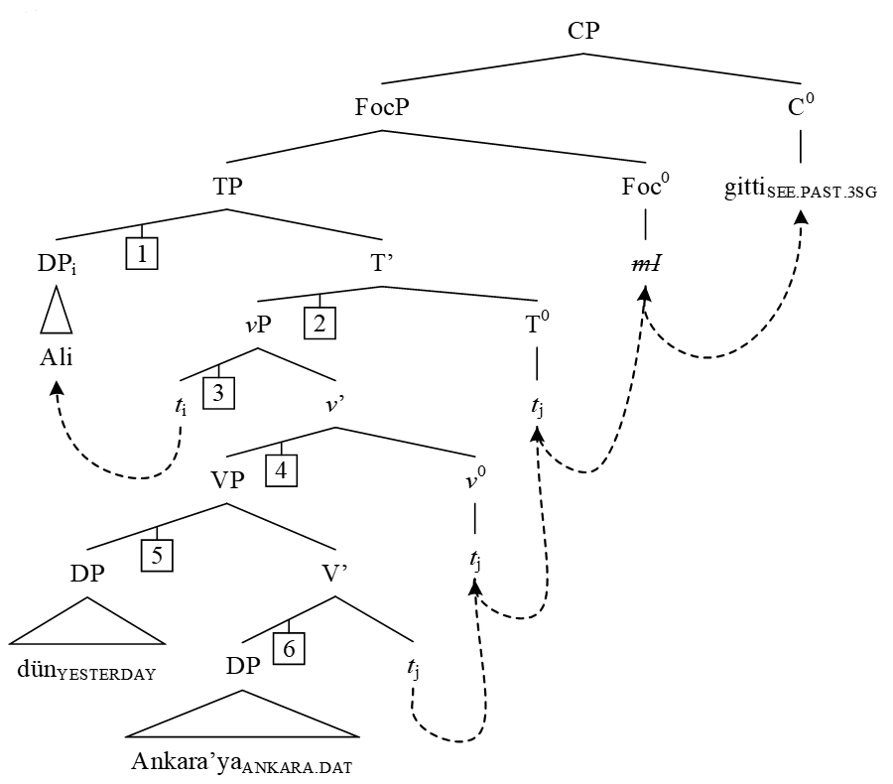
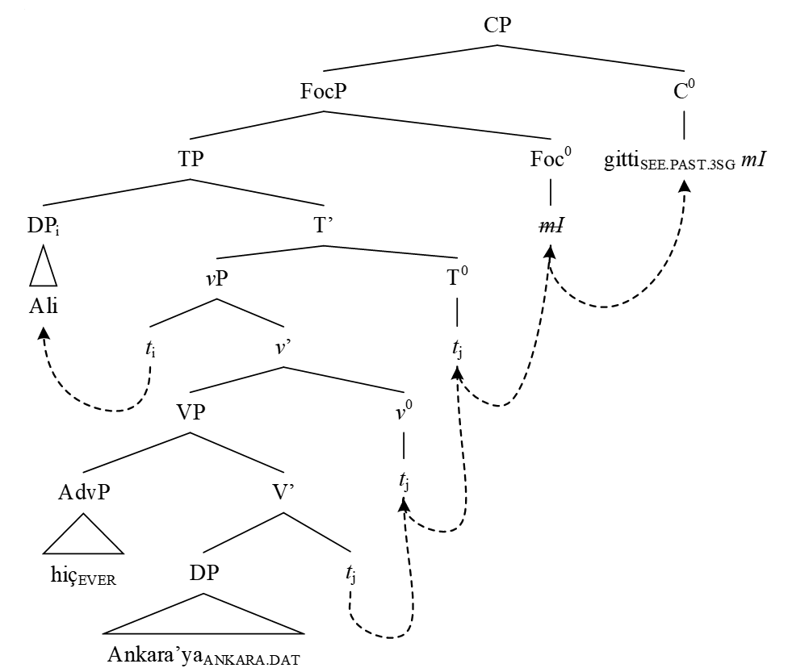
If mI originates in FocP (dominating TP) and is carried over to C with the verb, as in (5), a question arises as to how it ever ends up on a different constituent, as in (1). I argue for a placement algorithm (broadly based on Gračanin-Yuksek & Arsenijević, 2017), which limits the possible sites where mI can surface to positions that are adjoined to left daughters of every branching node in the c-command domain of mI, with the possible attachment positions illustrated through numbers from 1 to 6 in (6). The algorithm traverses the tree downwards starting from the sister of mI (TP), tracing the left branch of every branching node that it hits and placing mI as the sister of its left daughter, provided this node hosts overt material. If the left daughter is null, the algorithm proceeds with tracing the tree to the next branching node (along the right daughter), and then down the left branch again. The algorithm does not allow attachment of mI to right branches and only uses them to travel down the structure. This procedure can be repeated until there are no branching nodes left for the algorithm to traverse. In which of the positions allowed by the algorithm mI actually surfaces depends on what the speaker wants to focus on in the question. Thus, in Reading 1 in (1), mI occupies Position 1, marking the DP Ali. For Reading 2, mI is attached to the DP dün, namely, it occupies Position 5. Finally, for the ambiguity given in Readings 3 and 3' in (1), if mI is in Position 6, it scopes only over the object DP Ankara’ya, resulting in the narrow-scope reading (Reading 3 in (1)). However, if mI is in Position 2, then the reading we get is the wide-scope interpretation (Reading 3' in (1)) even if mI is pre-verbal. This is because mI scopes over the entire vP.

6)

The study also accounts for the relative order between mI and complementizers like diye ‘saying’, as well as for the interpretation of such sentences.
Selected References
Besler, D. (2000). The question particle and movement in Turkish (MA thesis). İstanbul: Boğaziçi University Göksel, A., & Kerslake, C. (2005). Turkish: A comprehensive grammar. London: Routledge. Gračanin-Yuksek, M., & Arsenijević, B. (2017, December). Auxiliary clitics in coordinated subjects: Agree – split – repeat. Paper presented at the Formal Description of Slavic Languages 12.5, Nova Gorica. Kamali, B. (2011). The question particle in Turkish: Consequences for the interfaces. Online Complement to Proceedings of WCCFL, 28. Kornfilt, J. (1997). Turkish. London: Routledge. Kural, M. (1993). V-to(-I-to)-C in Turkish. UCLA Occasional Papers in Linguistics, 11, 17-54. Özyıldız, D. (2015). Move to mI, but only if you can. In Workshop on Altaic Formal Linguistics (WAFL), 11, Presentation, 4-6. Progovac, L. (1994). Negative and positive polarity: A binding approach. New York, NY: Cambridge University Press.

